1. **Introduction**
   1. Purpose

The purpose of this project is to maintain proper health and diet control .This enables the user for a healthy lifestyle.

This is user friendly app.

* 1. Intended Audience

This app is for the people who feel insecure to come out in front of the large audience due to their body features and help them to loose/gain weight.

* 1. User Needs

In day to day life every one needs to check their diet plan with proper suggestions now and then due to ill health.

* 1. Scope

The scope for this project includes everything Trillium needs to replace their current system with our system in addition to a couple of extra features. The scope primarily consists of three parts, the database, the clinician portal, and the session application. The three of those parts each have a distinct scope.

### **Product’s Purpose**

* 1. Intended Audience and Reading Suggestions

The intended audience of this document is all major stakeholders which include the development team, the project owner, the project customer, the senior project advisor (Professor Hawker), and anyone evaluating the project. It is recommended that you check out our team’s website and the documents hosted there for better background on the project, process, and the team.

* 1. Definitions and Acronyms

If there is a failure of the app, this might lead to miscommunication and few medical problems. Keeping all these in mind we are trying to solve to minimize the problem.

1. **Functional Requirements**

The functionality of the project focuses on the user requirement. The Objective of the project helps to verify the functionality of the software. It describes what the product does. We defined the requirements of the core items of the Diet and workout using an iterative mixed method design approach that combines data derived from several sources.

* 1. The Diet and Workout application will be able to record exercise and repetitions.
  2. The Diet and Workout application will have an notification alert system.
  3. It will also have an overview look to see the improvement they have made. This feature is important because it will allow users to see their improvement.

1. **Interface Requirements**
   1. User Interfaces

The opening scene of the application will have diet plans , weight plans and overview. The user will then be able to interact with the dietitian and also with the trainer.From here the user starts in what exercises they have done that day and also how many repetitions as well as weight used.

* 1. Hardware Interfaces

The application will be accessible through the touch screen on an Android device. The Diet plan will be accessed by the dietitian and the workout plan will be accessed by the trainer.

* 1. Communications Interfaces

This application will not communicate with other users using the same applications. This app however will communicate with the android device in ways like the notifications.

1. **Performance Requirements**
   1. Response Time

The Diet and workout assistant should take approximately 10-15 seconds to load. Once an icon is clicked it should take about 5 seconds .

* 1. Platform

The diet and workout assistant will be for the software android versions.

1. **Other Non-Functional Attributes** 
   1. Security

The System shall not disclose and personal information about the customers. The Application shall not grant Access to an unauthorized user. The Application shall not communicate with other devices or servers while in use by the user.

* 1. Reliability

The Application shall not crash or close under any circumstances. The Application shall be able to recover in the event of a system failure in at least the time it takes to close the application and restart. The Application shall always be available to be used by the user.

* 1. Portability

This Application and its data should not be transferred to any other devices.

* 1. Maintainability

The Application shall be maintained by the developers in unison with Software or hardware updates. If the Application is to be changed the application shall go through detailed testing to determine the Reliability and Security of the Application.

* 1. Extensibility

The Application shall be modified with only minor changes to previous code. The application shall not be modified during run time or execution of the application.

* 1. Reusability

This Application shall provide instructions on how to use the application.

1. **Operational Scenario**

User opens the Application

User connects with the dietitian and they suggests a diet according to their body metabolism

User Connects to the trainer to perform some workout sessions to reduce their fat and maintain their proper health.

1. **Use Case**

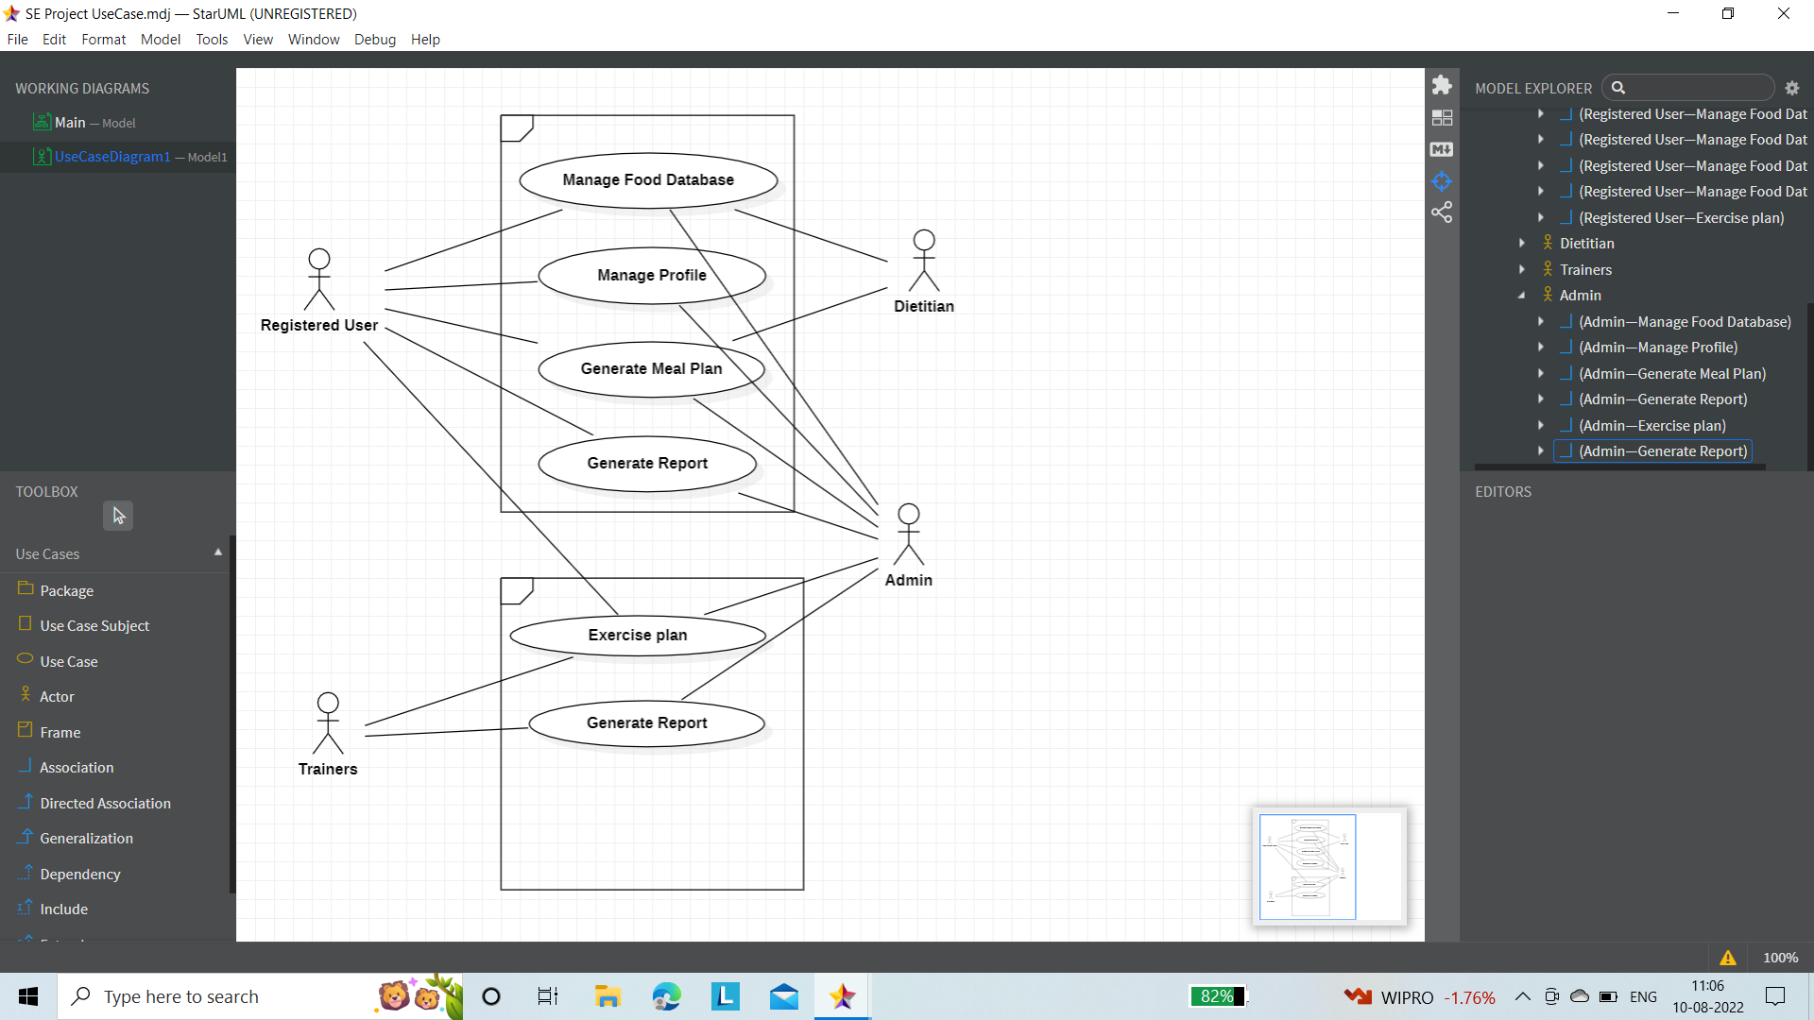

1. **Updated Schedule**

This section provides an up-to-date version of your team’s project plan, including the major tasks to be accomplished, their dependencies, and their tentative start/stop dates. The plan also includes information on hardware, software, and resources requirements.